Garment and colour choice | Available fit | Sizes | Price with Ballad Logo | Extra cost of boat logo/name | Total cost/garment | Number of each size
Polo with reveal | Ladies or Men’s (Unisex) | 8-20  XS-XXL | £16.00 | £3.00
White/navy

Pale blue/white

Navy/yellow

Plain polo | Ladies or Mens (Unisex) | 8-22  XS-6XL | £12.00 | £3.00
Yellow (Gold for 50th anniversary!)

Royal Blue

Navy

White

Zipped Fleece Jacket | Ladies or Mens (Unisex) | 8-22  XS-6XL | £24.00 | £3.00
Navy

Royal Blue

Red

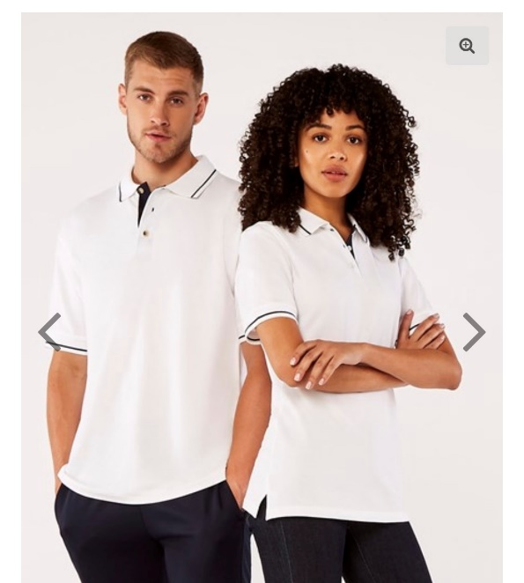
Polo with coloured reveal Men’s and ladies’ plain polo

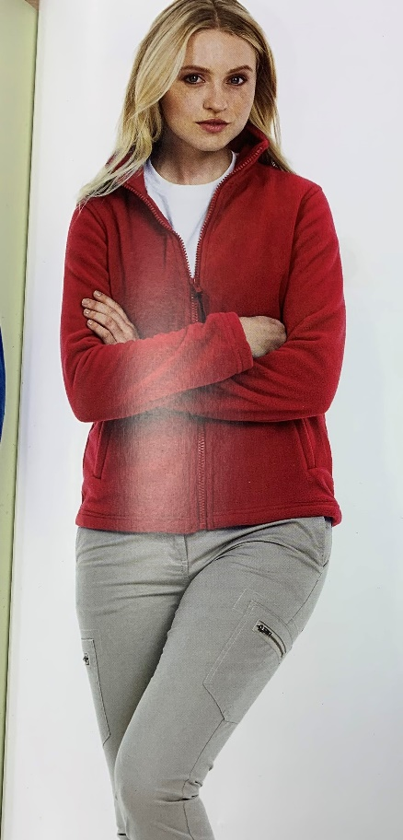
Men’s fleece Ladies fleece

