2019 Albin Ballad UK Open National Championships
Friday 24th – Monday 27th May

Organising Authority: RCYC Events Ltd,
Falmouth, Cornwall, UK

in conjunction with the Royal Cornwall Yacht Club

SAILING INSTRUCTIONS

RULES
  - The regatta will be governed by the rules as defined in the Racing Rules of Sailing 2017 – 2020 (RRS).
  - A rule in the Sailing Instructions shall take precedence over a rule in the Notice of Race. This changes rule 63.7.
  - Other changes to the racing rules will be made as follows:

Rule | See SI
33 | 12
35 | 15.4
44.1 | 14
60.1(a) | 16.5
62.1(a) | 3.2, 11.1(e), 11.1(g), 15.3
62.2 | 16.6
A4.2 | 11.1(f), 17.5
A4 | 15.4
A5 | 15.4

NOTICES TO COMPETITORS
Notices to competitors will be posted on the official notice board located at the Royal Cornwall Yacht Club (RCYC).

CHANGES TO SAILING INSTRUCTIONS
  - Any change to the sailing instructions will be posted before 0900 on the day it will take effect, except that any change to the schedule of races will be posted by 2000 on the day before it will take effect.
  - Oral changes on the water to these sailing instructions shall be broadcast on VHF channel 77. Failure to receive such broadcasts will not be grounds for redress. This changes rule 62.1(a).

SIGNALS MADE ASHORE
  - Signals made ashore will be displayed at the RCYC flagstaff.
  - When flag AP is displayed ashore, ‘1 minute’ is replaced with ‘not less than 60 minutes’ in the race signal AP.

SCHEDULE OF RACES
  - Racing will take place as shown below:

Dates of Racing | Level rated and white sail | Number of races
25 May | Championship racing | Up to 3
26 May | Championship racing | Up to 3
27 May | Pursuit Race | 1

  - The scheduled time of the warning signal for the first race each day on Saturday and Sunday is 1100.
  - To alert boats that a race or sequence of races will begin soon, the orange starting line flag will be displayed with one sound at least five minutes before a warning signal is made.
  - No warning signal will be made after 1500 on Sunday.
  - The first boat to start in the pursuit race on Monday will start at approximately 1000.

CLASS FLAG
The Class flag will be flag “F”.

RACING AREAS
  - Racing on Saturday and Sunday will take place in Falmouth Bay or adjacent areas to the east (areas A and B on the diagram at Addendum A). If conditions in the Bay are unsuitable racing may be held in the Carrick Roads (area C).
  - The pursuit race on Monday will take place between Falmouth and the Fowey area.

THE COURSES
  - The diagram in Addendum B shows the championship course on Saturday and Sunday.
  - The courses on Saturday and Sunday are shown in the table at Addendum B and the order in which marks are to be passed All marks are to be left to port.
  - The course to be sailed will be displayed on a board at the stern of the committee boat and will be broadcast on VHF channel 77.
  - No later than the warning signal, the race committee signal vessel may display the approximate compass bearing of the first leg.
  - The course for the pursuit race on Monday will be published by 2000 on Sunday and may be announced on channel 77 before the start of the race.

MARKS
The marks on Saturday and Sunday will be red or orange cylindrical buoys. The marks on Monday will be fixed Admiralty marks.

AREAS THAT ARE OBSTRUCTIONS
  - Commercial and military shipping. Commercial and military shipping under way and constricted in their ability to manoeuvre are designated as moving exclusion zones. The exclusion zone extends to 100m on all sides of the vessel and includes tugs, race committee escort boats and pilot boats. No boat shall enter the exclusion zone and if becalmed may use any means of propulsion to move out of the way. This should only be sufficient to leave the exclusion zone by the safest possible route and offer the competitor no significant advantage in the race.
  - Divers. Exclusion zones extend 25m around a dive boat displaying code flag A, an inflatable orange buoy marking a diver just under the surface, and a diver on the surface. A boat shall not enter the 25m zone.
  - Prototype energy device. Competitors shall not enter the box described by the four cardinal marks surrounding the device deployed under the surface at 50⁰ 06'.273 N, 004⁰ 59'.639 W. The coordinates of the four cardinal marks are:
North Cardinal 50⁰ 06'.327 N 004⁰ 59'.641 W
East Cardinal 50⁰ 06'.274 N 004⁰ 59'.555 W
South Cardinal 50⁰ 05'.165 N 004⁰ 59'.632 W
West Cardinal 50⁰ 06'.272 N 004⁰ 59'.723 W

See also Falmouth Harbour Port Notice to Mariners No 07 / 2019.

THE START
  - Racing on Saturday and Sunday.
    - The committee boat is the white hulled sloop “Eseld”. The committee boat will describe its approximate position on VHF channel 77 approximately 30 minutes before the first scheduled warning signal.
    - The starting line will be between the mast on the committee boat, displaying an orange flag, and a dan buoy with an orange flag.
    - Boats whose warning signal has not been made shall avoid the starting area during the starting sequence of other races.
    - An attention signal (orange flag displayed with one sound signal) will be made five minutes before the warning signal. The race committee will designate the course to be sailed before or with the attention signal.
    - The course to be sailed, count down, postponement, and general recall, will, where possible, be broadcast on VHF channel 77. Failure to make a broadcast or to time it accurately shall not be grounds for a request for redress. This changes rule 62.1(a).
    - A boat starting later than four minutes after her starting signal will be scored “Did Not Start” without a hearing. This changes rule A4.2.
    - If any part of a boat’s hull, crew or equipment is on the course side of the starting line during the two minutes before her starting signal and she is identified, the race committee will attempt to broadcast her sail number on VHF. Failure to make a broadcast or to time it accurately will not be grounds for a request for redress. This changes rule 62.1(a).
  - The pursuit race on Monday.
    - The start line will be a line extending east from a transit formed by the orange triangle and the PoFSA signals mast on Pendennis Point at the west side of the entrance to Falmouth Harbour. Boats shall start by crossing from north to south. The line will be bounded at the port end by the Black Rock isolated danger mark, and at the starboard end by the shore. Black Rock and the shoreline of Pendennis Point have outlying reefs. Competitors are advised to familiarise themselves with the extent of these reefs on an appropriate chart, and keep clear.
    - Start times for all boats will be published by 2000 on Sunday.

CHANGE OF THE NEXT LEG OF THE COURSE
Marks may be moved by not more than approximately 200m and/or approximately 10 degrees without signalling. This changes rule 33.

THE FINISH
  - Racing on Saturday and Sunday. The finishing line will be between the mast on the committee boat, displaying an orange flag, and a dan buoy with an orange flag.
  - The pursuit race on Monday. The finishing line will be in the Fowey area. The exact location will be published by 2000 on Sunday.

PENALTY SYSTEM
Rule 44.1 is changed so that the Two-Turns Penalty is replaced by the One-Turn Penalty.

TIME LIMITS AND TARGET TIMES
  - Time limits and target times are as follows:

Target time | Finish Window | Time limit | Mark 1 time limit
90 minutes | 30 minutes | 120 minutes | 40 minutes

  - If no boat has passed Mark 1 by the Mark 1 time limit the race will be abandoned.
  - Failure to meet the target time will not be grounds for redress. This changes rule 62.1(a).
  - Boats failing to finish within the Finish Window after the first boat sails the course and finishes will be scored Did Not Finish without a hearing. This changes rules 35, A4 and A5.

PROTESTS AND REQUESTS FOR REDRESS
  - Protest forms are available from the RCYC Sailing Office. Protest and requests for redress or reopening shall be delivered there within the appropriate time limit.
  - For each class, the protest time limit is 90 minutes after the last boat has finished the last race of the day or the race committee signals no more racing today, whichever is later.
  - Notices will be posted no later than 30 minutes after the protest time limit to inform competitors of hearings in which they are parties or named as witnesses. Hearings will be held in the protest room, located at YYC, beginning at the time posted.
  - Notices of protests by the race committee, technical committee or protest committee will be posted to inform boats under rule 61.1(b).
  - Breaches of SIs 11.1(c) and 27 will not be grounds for a protest by a boat. This changes rule 60.1(a).
  - On the last scheduled day of racing a request for redress based on a protest committee decision shall be delivered no later than 30 minutes after the decision was posted. This changes rule 62.2.

SCORING
  - 4 races are scheduled.
  - 2 races are required to be completed to constitute a series.
  - When fewer than 4 races have been completed, a boat’s series score will be the total of her race scores.
  - When 4 races have been completed, a boat’s series score will be the total of her race scores excluding her worst score.
  - A boat that started on the course side (OCS) or was disqualified under rule 30.2 (UFD), rule 30.3 (BFD), did not finish (DNF), or retired after finishing (RAF), shall be scored points for the finish place one more than the number of boats that competed in the race. A boat that did not start (DNC or DNS) or was disqualified other than under RRS 30.3, (DSQ, DNE or DGM) shall be scored points for the finishing place one more than the number of boats entered in the series. This changes rule A4.2.

SAFETY REGULATIONS
  - All boats shall carry a working marine VHF transceiver.
  - Any boat that retires shall inform the committee boat as soon as possible on VHF channel 77. If unable to do so, they shall inform the race office by telephone (01326 211555) at the first opportunity.
  - Competitors shall obey safety instructions given by safety or mark laying boats displaying flag “R” in relation to commercial shipping movements and divers.

RADIO COMMUNICATION
Except in an emergency, a boat that is racing shall not make voice or data transmissions and shall not receive voice or data communication that is not available to all boats. [DP]

PRIZES
  - Class Association trophies will be awarded as follows:
UK Open National Championship (Spinnaker Division)
Jean Ellis Memorial Trophy Overall winner
Upper Deck Trophy 2nd overall
Toms Trophy 3rd overall
Pam Sheridan Trophy Highest placed Fowey yacht (after the first 3 overall)
Rocky’s Spoon Last boat overall
UK Open National Championship (White Sail Division)
Corinthian Trophy Overall winner
Pursuit Race
Old Ferry Inn Trophy Winner
Other Trophies
The Julian Foye Trophy Concours d’Elegance
Noakes and Habermehl Voyager TrophY Boat travelling furthest from her home port to the championship
Variety Trophy Best endeavour
  - Engraved glassware will be awarded to the boats placed 1st, 2nd and 3rd in the overall series and, for each individual race, to the highest placed boat not already winning an individual race prize. In addition, mementos of the championship will be presented to each competing boat.

DISCLAIMER OF LIABILITY
  - Rule 4 of the Racing Rules of Sailing states: “The responsibility for a boat’s decision to participate in a race or to continue racing is hers alone”.
  - Sailing is by its nature an unpredictable sport and therefore inherently involves an element of risk. By taking part in the event, each competitor agrees and acknowledges that:
    - They are aware of the inherent element of risk involved in the sport and accept responsibility for the exposure of themselves, their crew and their boat to such inherent risk whilst taking part in the event;
    - They are responsible for the safety of themselves, their crew, their boat and their other property whether afloat of ashore;
    - They accept responsibility for any injury, damage or loss to the extent caused by their own actions and omissions;
    - Their boat is in good order, equipped to sail in the event and they are fit to participate;
    - Provision of a race management team, patrol boats and other officials and volunteers by the event organiser does not relieve them of their own responsibilities;
    - Provision of patrol boat cover is limited to such assistance, particularly in extreme weather conditions, as can be practically provided in the circumstances;
    - It is their responsibility to familiarise themselves with any risks specific to this venue or this event drawn to their attention in any rules and information produced for the venue or event and to attend a safety briefing held for the event;
    - They are responsible for ensuring that their boat is equipped and seaworthy so as to be able to face extremes of weather; that there is crew sufficient in number, experience and fitness to withstand such weather; and that the safety equipment is properly maintained, stowed and in date and is familiar to the crew.

INSURANCE
Each participating boat shall be insured with valid third-party liability insurance with a minimum cover of £2,000,000 per incident or the equivalent.

ADDENDUM A: RACE AREAS ON SATURDAY AND SUNDAY

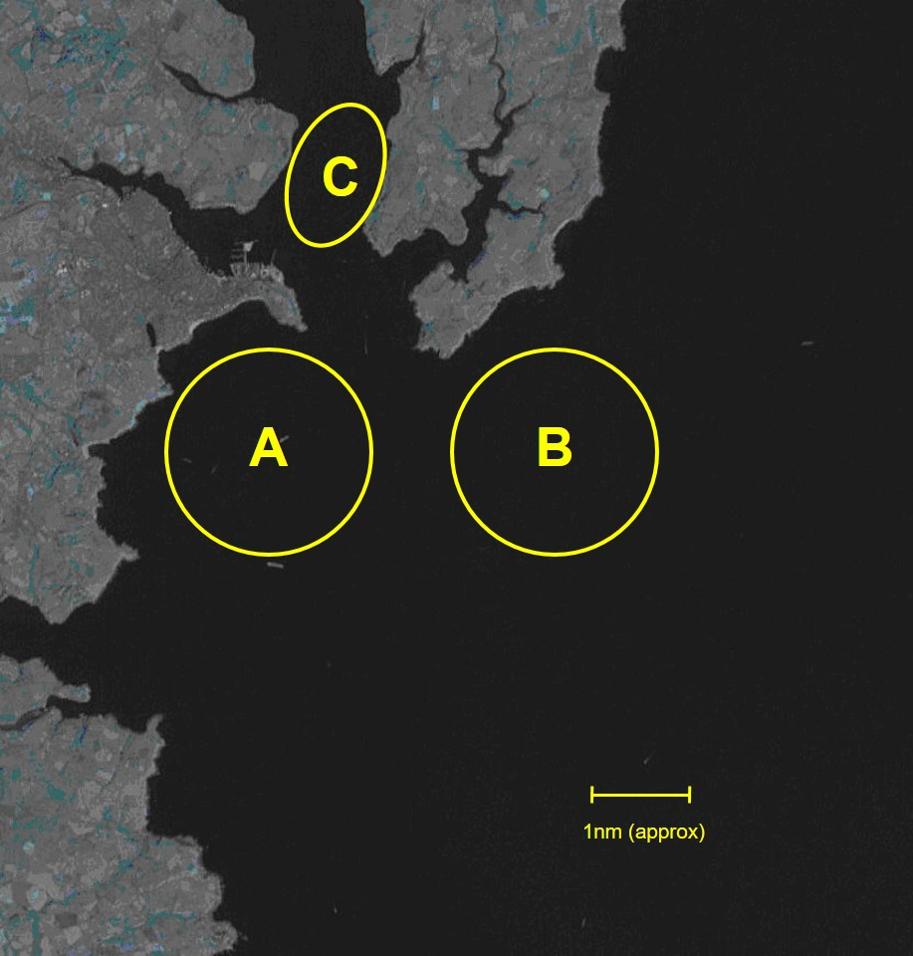

ADDENDUM B: COURSES ON SATURDAY AND SUNDAY

Indicative diagram

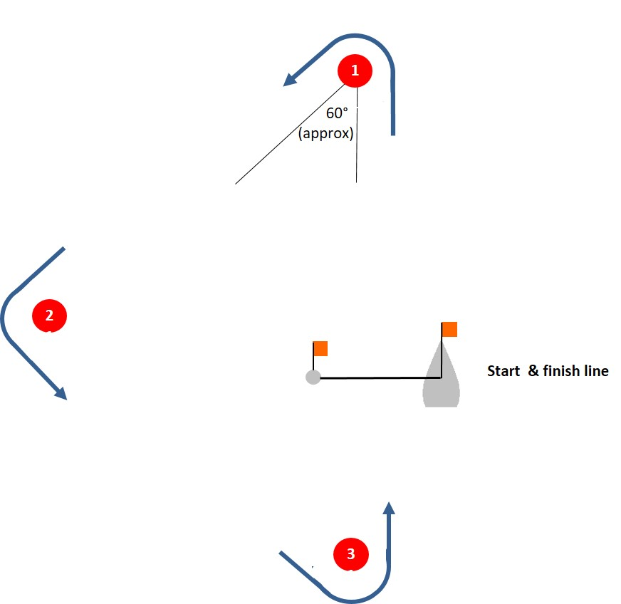

Course | Order of mark roundings
1 | Start – 1 – 2 – 3 – 1 – 3 – 1 – 2 – 3 – Finish
2 | Start – 1 – 2 – 3 – 1 – 3 – Finish
3 | Start – 1 – 3 – 1 – 3 – Finish
4 | Start – 1 – 3 – 1 – 2 – 3 – 1 – 3 – Finish
5 | Start – 1 – 3 – 1 – 2 – 3 – Finish

